English samples

product name: SQUASH / KALABASA

product description: Squashes are **considered to be fruits** because they contain seeds and develop from the flower-producing part of a plan

product price: 40.00

product type: vegetables

product measurement: KILO

product quantity: 100 pcs

product picture/image(3 samples different figures):

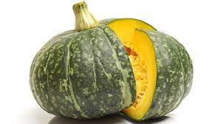 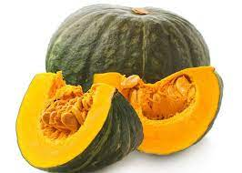 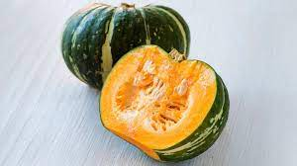

English samples

product name: CHICKEN / MANOK

product description: LIVE CHICKEN

product price: 100.00

product type: livestock

product measurement: pieces

product quantity: 220

product picture/image(3 samples different figures):

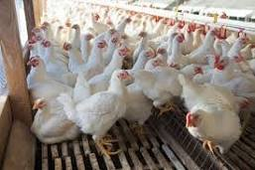 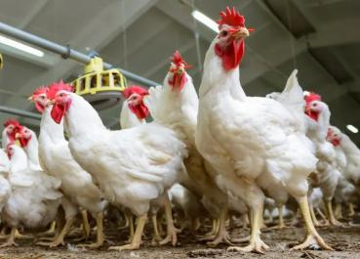 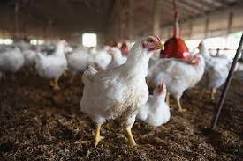

English samples

product name: EGGS

product description: Brown organic eggs Medium/Large

product price: 95.00

product type: poultry

product measurement: dozen

product quantity: 85

product picture/image(3 samples different figures):

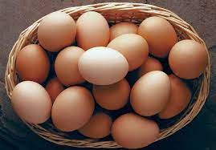 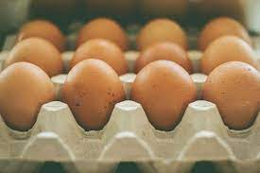 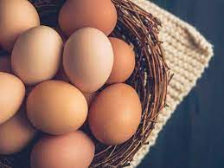

English samples

product name: BANANA / SAGING

product description: LAKATAN

product price: 225.00

product type: FRUITS

product measurement: BOX

product quantity: 50

product picture/image(3 samples different figures):

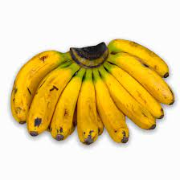 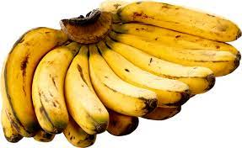 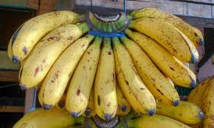

English samples

product name: CARROTS

product description: The carrot (Daucus carota subsp. sativus) is **a root vegetable**

product price: 50

product type: VEGETABLES

product measurement: KILO

product quantity: 120

product picture/image(3 samples different figures):

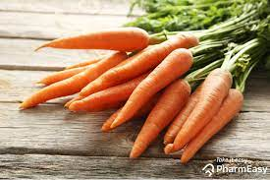 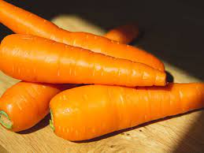 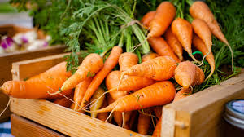

English samples

product name: PIG

product description:

product price: 3500

product type: LIVESTOCK

product measurement: PIECES

product quantity: 10

product picture/image(3 samples different figures):

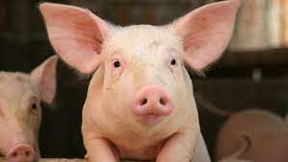 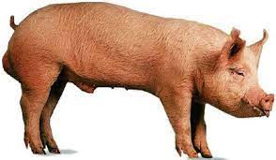 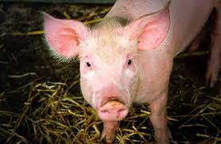

English samples

product name: GARLIC / BAWANG

product description: BAWANG

product price: 20

product type: VEGETABLES

product measurement: KILO

product quantity: 250

product picture/image(3 samples different figures):

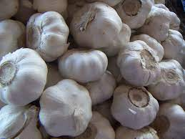 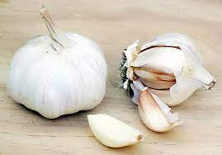 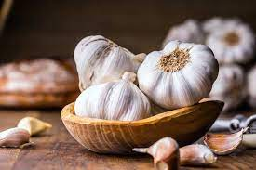

English samples

product name: CABBAGE

product description: GREEN CABBAGE

product price: 15

product type: VEGETABLES

product measurement: KILO

product quantity: 25

product picture/image(3 samples different figures):

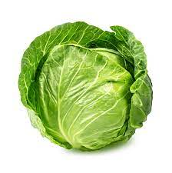 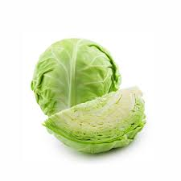 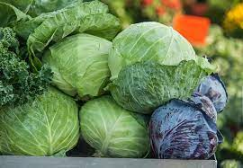

English samples

product name: BITTER MELON / AMPALAYA

product description:

product price: 25

product type: VEGETABLES

product measurement: KILO

product quantity: 50

product picture/image(3 samples different figures):

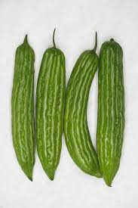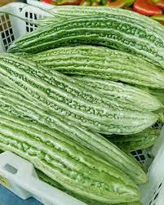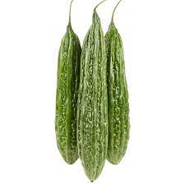

English samples

product name: MANGO

product description: ****Kesar**** - This Indian variety is a fiber-free sweet mango that can vary in color from green to yellow with a round shape

product price: 230

product type: FRUITS

product measurement: BOX

product quantity: 20

product picture/image(3 samples different figures):

